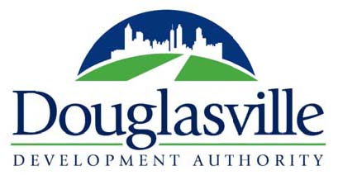

**April 10, 2025**

**9:00 AM**

**8512 Bowden Street**

1. Call to Order
2. Roll Call
3. Reading and approval of the minutes
4. Budget Report
5. New Business

* Approval of sponsorship of Douglasville Civic Dinners in the amount of $5000
* Approval of Fiscal Year 2026 Budget
* Nominate and appoint a Chair of the City of Douglasville Development Authority for a 1-year term, ending April 11, 2026
* Nominate and appoint a Vice-Chair of the City of Douglasville Development Authority for a 1-year term, ending April 11, 2026

1. Other Business
2. Project Updates
3. Set Date of Next Meeting — May 8, 2025
4. Adjournment